Notes from Local Interest Group 30th March 2023

Present: Maureen Lloyd (ML), John Price, Wendy Ozols, Tim Francis, Brian Morgan, Joan Lloyd, Janet Russell, Roy & Avryl Lloyd, George & Eleanor Watkins, Samantha Abbott, Cherry & Victor Williams, Malc Gonnella, Sue Lawler, Mollie Moore, Tim East, Helen Simmons, Ron Francis, Helen Barnett, Sally Holtermann, Grace Davies
On Zoom: Dainis Ozols, Sylvia Illingsworth, Margaret Price, Mike Head
ML welcomed everyone and also introduced the speaker for the evening, Tim Francis, who lives in Rhosgoch.
Full Circle for a Local Boy (Back where I started)
Tim began his talk with a little family history. His paternal grandparents moved a great deal, but from around 1920 to the early 1940s they lived at Llandeviron. His maternal grandparents were from Tylemawr, Fynnon Gynydd. The farm where he was born, and where his parents lived, was Penywrlodd, Clyro, although his birth certificate says Painscastle. Tim went to school in Clyro and then moved on to the Grammar School in Llandrindod Wells.
In 1968, and aged 16, he left school and decided to join the army, feeling that farming seemed like much too hard work for his liking! Initially, he was on a two-year Junior Leader Surveying Apprenticeship and this was followed by four years mainly spent in Germany on Cold War surveying duties. He also had two tours of duty in Northern Ireland in the early 1970s, a particularly dangerous time to be serving in the province – during “the troubles”. In 1971/72, he was the youngest (at 19 years of age) in his unit serving in South Armagh, where he spent much of his time in ditches and hedges and even, on one occasion, in a convent! This area was known as “Bandit Country”. (One of his friends from this unit later moved to Lima where he opened a pub, and Tim went to visit him in 2018, the first time he had seen him since 1974.) In 1973/74, he had another posting to N. Ireland, this time in Londonderry, which was a very dangerous place at that time. These tours in N. Ireland were very hard and the soldiers often worked 18 hour days. (He went back to Londonderry in 2009, by which time the city had changed significantly, although some reminders of the troubled times can still be seen.)
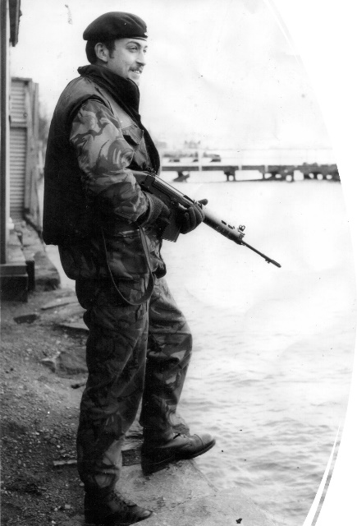
Tim in Londonderry 1974
By 1974, Tim decided that he had had enough of the army and so he left and moved to London, where he worked in John Lewis’ computer department for a while, but he did not enjoy this work. In 1975, he met his future wife, Vida, who was from Iran. When they decided that they would like to get married, Tim was “vetted” by his future mother-in-law, who decided that he was a suitable husband for her daughter, on the condition that he move to Iran to live and work. So, in August 1976, he arrived in Tehran which, at the time, was a very polluted city, especially the parts that were on the lower ground. Tim showed us a picture of the city dating from that time and with the Shahyad/Azadi Tower in the background. This is a major landmark in the city and was originally built in 1971 as a memorial to 2500 years of Iran’s monarchy. When the monarchy was abolished 8 years later, the tower was renamed the Freedom Tower. It was constructed using 8000 blocks of marble and is 150ft high.
Tim got his first job in Iran within four weeks of being in the country, in September 1976. This job was near Yasuj, a very remote part of the country which involved an 18 hour bus journey to reach. His employers were a joint Iranian/Israeli venture and he worked as a surveyor on a project building roads to connect the villages in this remote area. The work had to be done quickly and, because all of the field data had to go to Israel for plotting, Tim had to do a crash course in Hebrew. His workmates on this venture were both Israelis and Iranians, and he is still in touch with one of the Israelis. When he was working there, Yasuj was a small town, with a population of about 4000 in 1976. By 2016, it was a city of 135 000 and it even has an international airport.
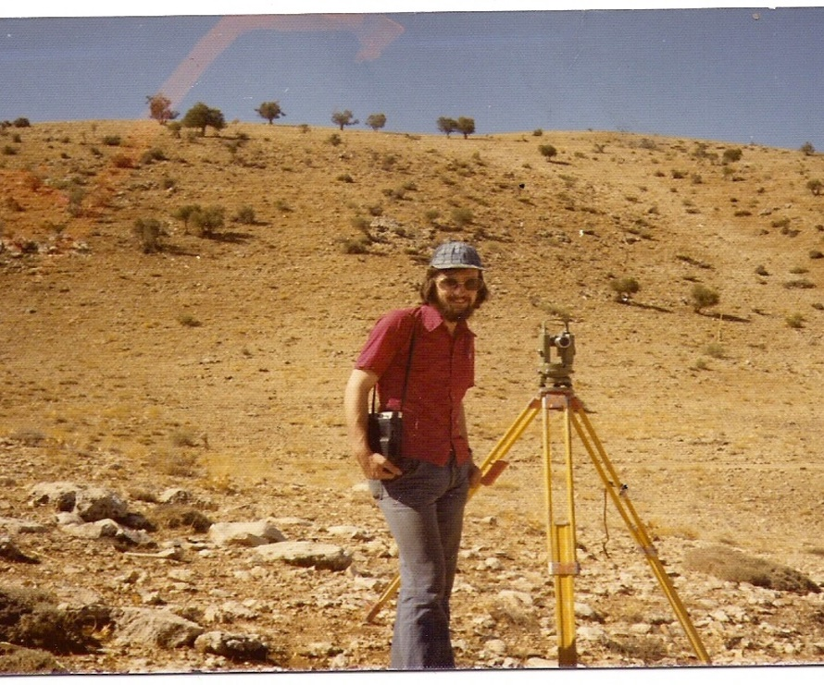
Tim in Yasuj in 1976
Tim’s next job was in Isfahan, a very beautiful place with a central square called Naqsh-e-Jahan, which means “map of the world”, built in around 1600. There is a beautiful, 33-arch bridge over the river which was built between 1599 and 1602 and the Royal Mosque, which dates from 1629. Most of Isfahan was built by Shah Abbas in the 1600s. This new job involved surveying for a new township and Tim was in charge of this project. (This new project became the Natanz Nuclear Facility 40 years later, but this is not what was originally planned.)
In May 1977, Tim and Vida got married and his family from the UK went over to Iran for the occasion. In fact, because of local traditions and customs, as well as legal requirements, he was married three times! The wedding took place in the Imperial Officers Club in Tehran.
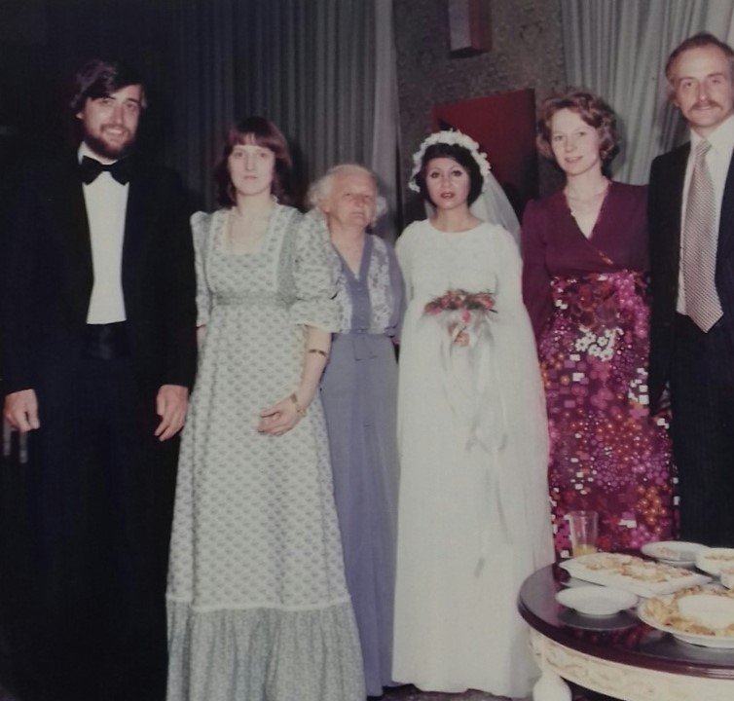
Tim and Vida, with Tim’s Family, at their wedding in 1977
After his wedding, Tim went to work in Ahwaz, the centre of Iran’s oil industry. His employers were IJPC, the Iran Japan Petroleum Company. Once again he was working with people from other countries; there were three Israelis and three Americans as well as him. This part of Iran can be extremely hot, reaching 50°C+ and it felt even hotter in the oil installations. Because of the gas being burned off from the oil wells, this area was very polluted. Two of his friends here, Dan and Aviel, were Israelis and, in 2016, Tim visited Israel and was given a tour by Dan. (Very sadly, Aviel was killed in 2002 by a Hamas group suicide bomber.)
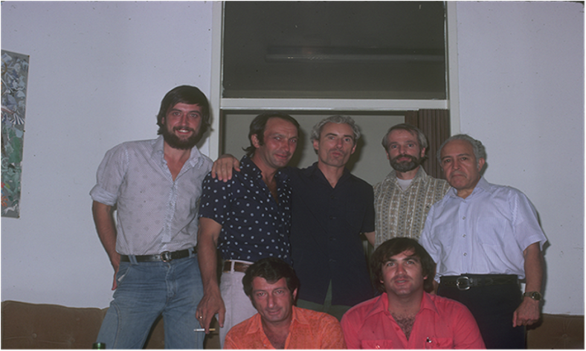
Tim with his colleagues from IJPC in Ahwaz
Once the work with the IJPC was complete, Tim was given work, in January 1978, on a six month contract to Iran’s main oil company, to do a survey for a drilling platform for a new well in Agha Jari. However, this work came to an end in May and Tim returned to Tehran where he found a new job, again very quickly. He worked for Sir Alexander Gibb and Partners, who specialized in water-related projects worldwide. The work involved supervising the installation of the sewerage system for a new Tehran satellite town, Farahzad, which was planned to have a population of 250 000. Tim said that this was one of the best jobs he has ever had.
This was a strange time in Iran because the Revolution was happening. By August 1978, the country was under martial law, and Tim saw large gatherings of people on the streets in Tehran. By the time of the actual Revolution in early 1979, Tim and Vida were in the UK, but they returned to Iran quite quickly. However, all construction projects were suspended and Tim found himself out of work, so he took a job teaching English to private students.
By May 1979, Tim had found work at Minou Island, Abadan, where three projects were starting up again. One of these was a road project, and there was also a bridge site survey to be done which involved Tim using a naval gunboat as the river was very wide at this point. This was also an extremely dangerous location and so Tim was armed most of the time. Iraq, and Basra, could easily be seen across the river (this is where the Tigris and Euphrates have their confluence, the Shatt-al-Arab) – this would become a war zone during the Iran-Iraq war 18 months later. The work here involved putting in sheet piles to protect the river banks from erosion from the wash from the large Iraqi oil tankers which used these waters.
He “escaped” from this region and was, once again, employed by Sir Alexander Gibb and Partners, this time on the Lar Dam and Tunnels Project; he was to be the senior surveyor on this huge project – the 12th largest dam and reservoir in the world and valued at £600 million in 1974. This was a complicated project because the area is seismically active and reservoirs can initiate earth tremors themselves. The dam is an earth-fill dam, 1500m high at the crest and 106m long. The reservoir behind was planned to be over 20km long. 12km of tunnels had to be built to link the dam to the Kalan hydroelectric power station. There was a township for the workers, and Tim lived here during the week. He was still working on this project in 1983, helping to investigate problems with the unexpectedly slow filling of the reservoir. Eventually, after much research, it was found that water was leaking into sinkholes. In the same year, his contract was terminated and he found himself without a passport for four months because it had been confiscated. The British embassy in Tehran was not particularly helpful, but Tim did eventually manage to leave the country and move back to the UK.
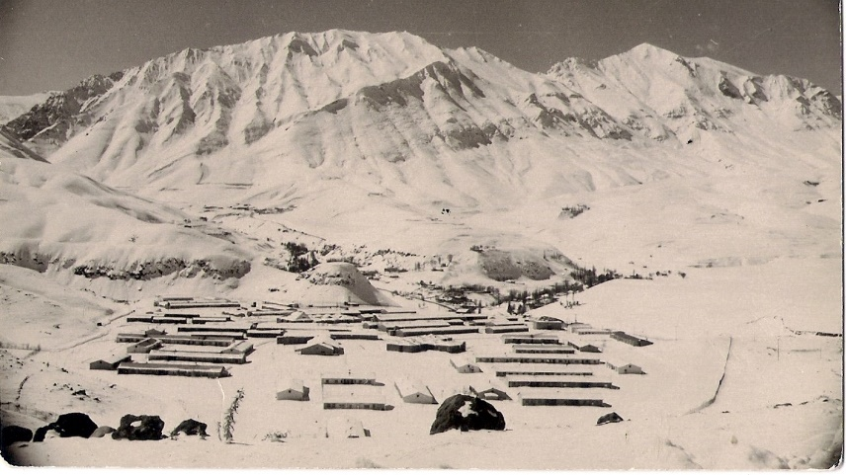
Lar Staff Township – it was very cold in winter!
Initially Tim lived in Reading and then in Gloucestershire, before moving to Rhosgoch in 2008. During the 1990s, he worked at Credenhill, outside Hereford, where he was in charge of construction projects for the MoD. Between 2004 and 2012, he was Project Co-ordinator and Deputy Project Director on the Queen Elizabeth Hospital, Birmingham project, the biggest hospital in the UK outside of London. Between 2012 and 2014, he worked on the Bristol Southmead Hospital project and he has also been involved in work on a number of other hospitals, nationwide. He is now happily retired and living in Rhosgoch where he is an active member of the local community – coming round full circle, back to his original home.

ML thanked Tim for an extremely interesting evening. What a life for a local boy who “spread his wings” aged just 16 and who has seen and experienced things that the rest of us can only imagine. What an eventful career he has had. We all thoroughly enjoyed his talk and came away having learned a great amount about a country of which most of us know very little.

The evening ended as always with refreshments, kindly made by Avryl Lloyd, ably assisted by Helen Barnett; many thanks to them. This is always a great opportunity for chat and reminiscing. Many thanks as always go to John Price for his work on connecting the Zoom audience and also for recording the talk. As always, we are most grateful to him.

